Experiments

Program-1]print message
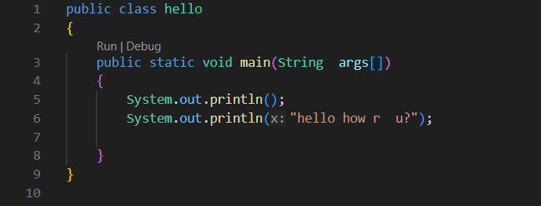

Program-2]different type of variable using different variable
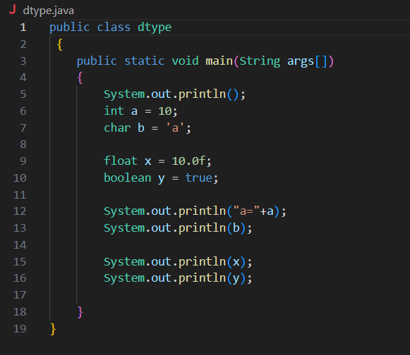
Program:3] type casting/type conversation
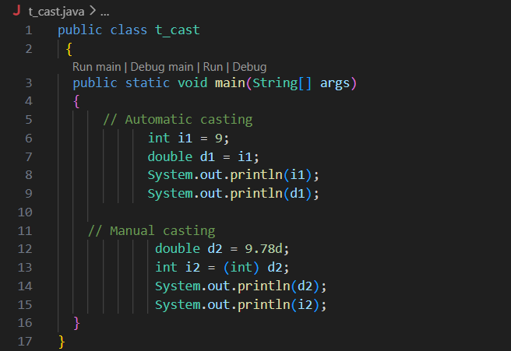

Program-4]Assignment operator
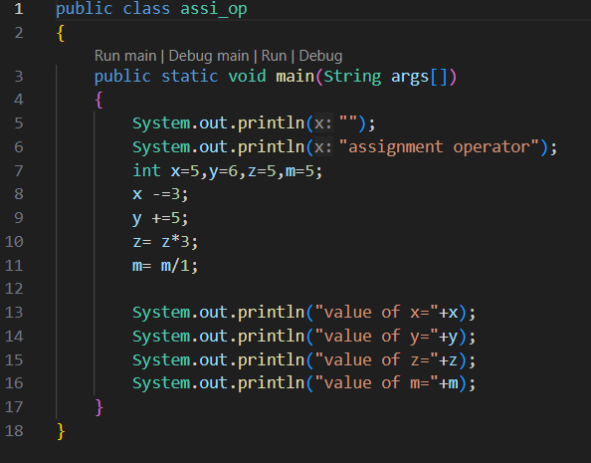

Program-5] different type of looping structure
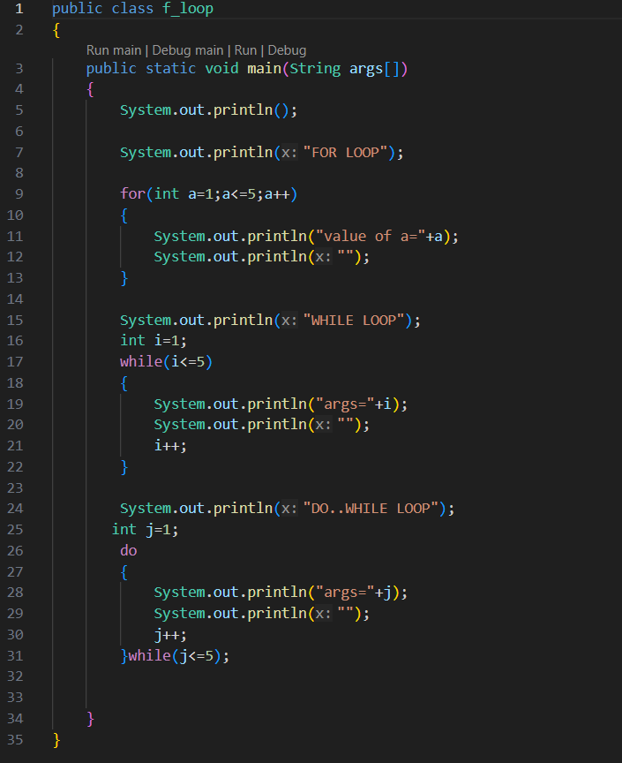

Program:6]print output of 1 to 5 number in pyramid format
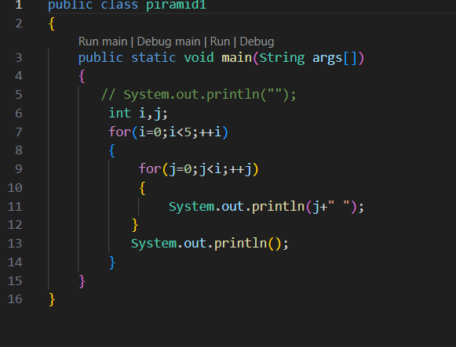

Program:7] Create calculator using switch case statement
